**Introduction:**

This report is about the development of a data base schema for ABC company, an online shop that sells items all over Europe. The goal is to store and manage customer information, product information, orders, returns and comments.

The objectives of the project are:

* Data base schema (ER Diagram)
* Implementing the data base with Maria db.
* Add sample data
* Write sql queries relevant to the database and business problem

**Data base design:**

**ER Diagram:**

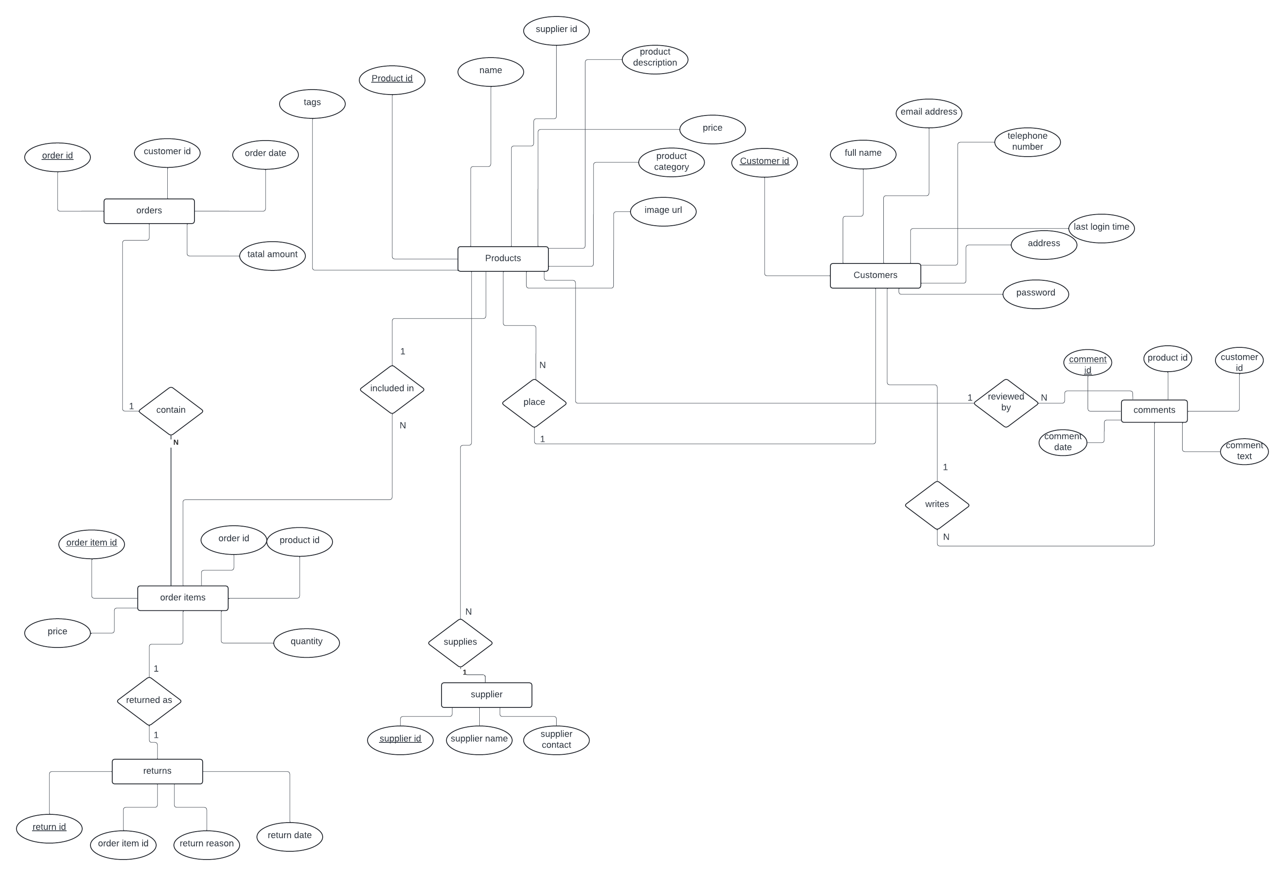

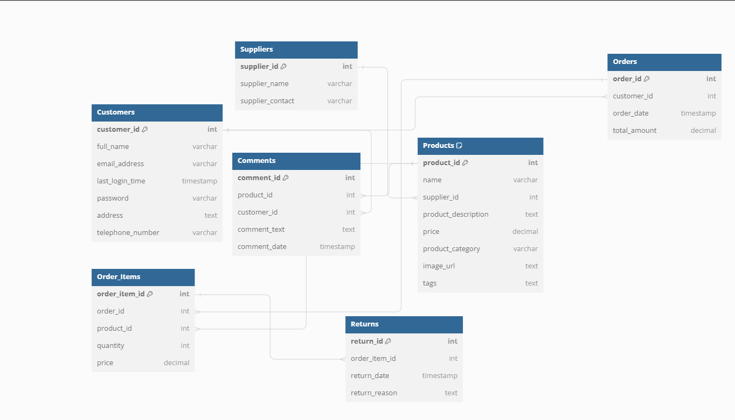

**Tables:**

* Customers: contains customer info:

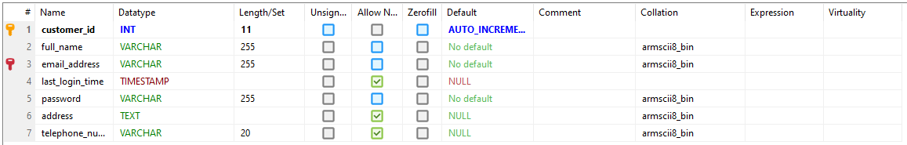

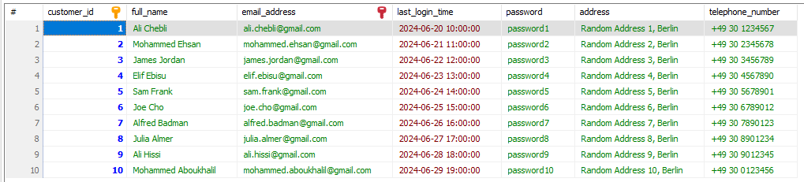

* Products: Contains product information:

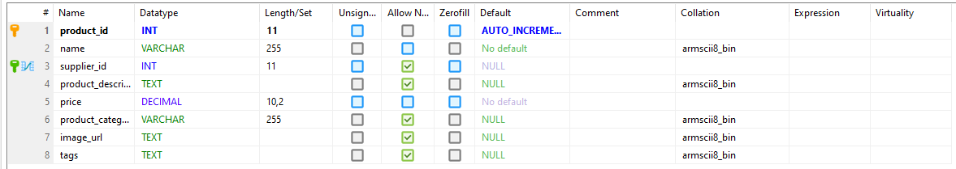

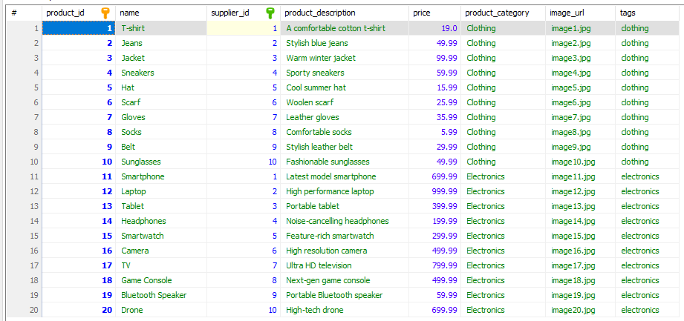

* Orders table :Has order details

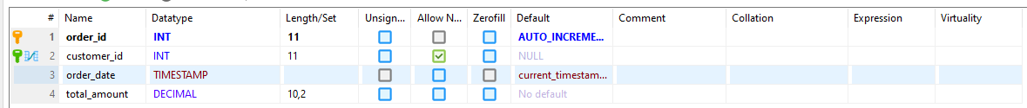

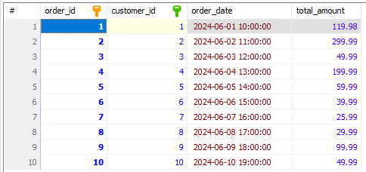

* Order items : contains items that are in each order :

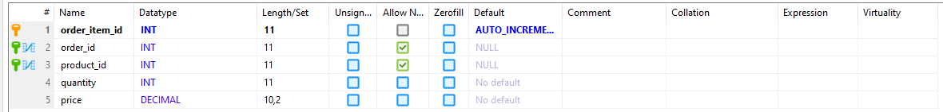

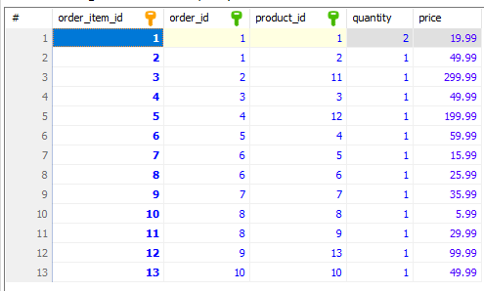

* Suppliers : contains supplier details:



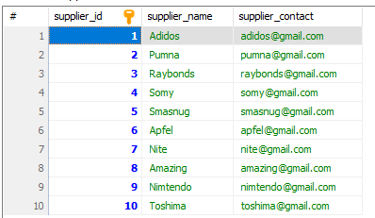

* Comments: stores comment data

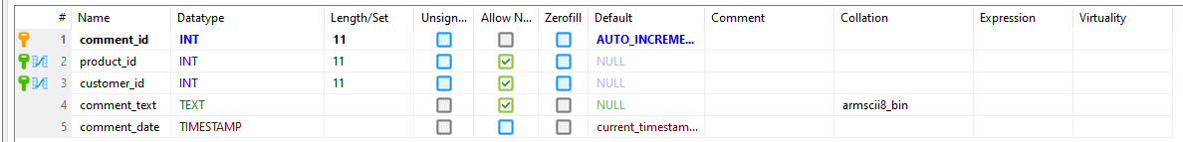

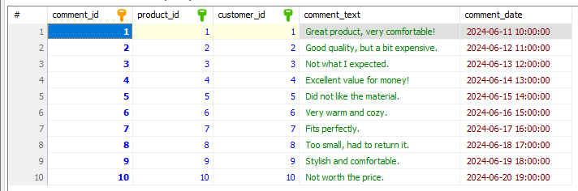

* Returns table stores data about the returned items :

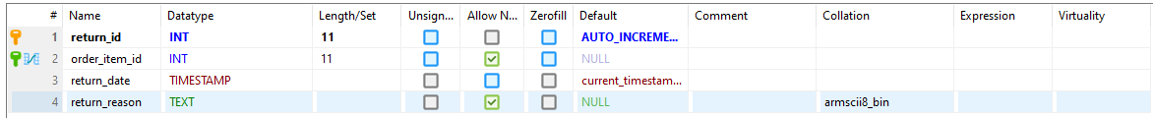

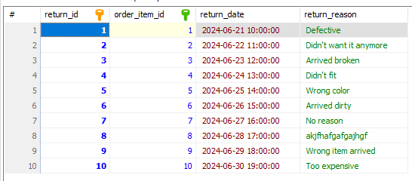

The relationships in this data base are:

Customer – (1) one to many(N)-> Order

Order – (1) one to many(N)-> Order Item

Product – (1) one to many(N)-> Order Item

Supplier – (1) one to many(N)-> Product

Product – (1) one to many(N)-> Comment

Customer – (1) one to many(N)-> Comment

Order Item – (1) one to one (1)-> Return

The database has primary keys to make each table unique , and foreign keys to connect tables together.

It also has constraints to ensure data integrity. (e.g., NOT NULL, UNIQUE).

**Database implementation:**

The data base was implemented using Maria db.

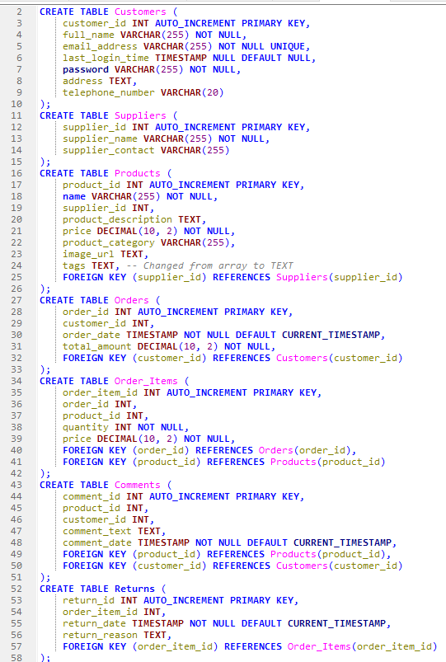

**Database population:**

**Populating Customers table:**

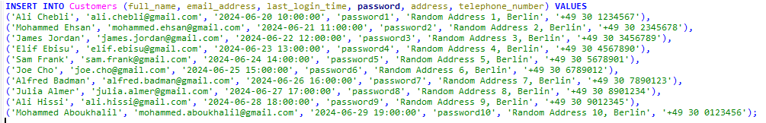

**Populating suppliers table:**

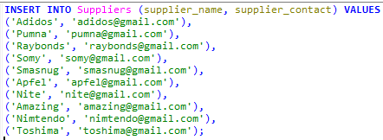

**Populating Products table with 2 types of products (electronics and clothing’s):**

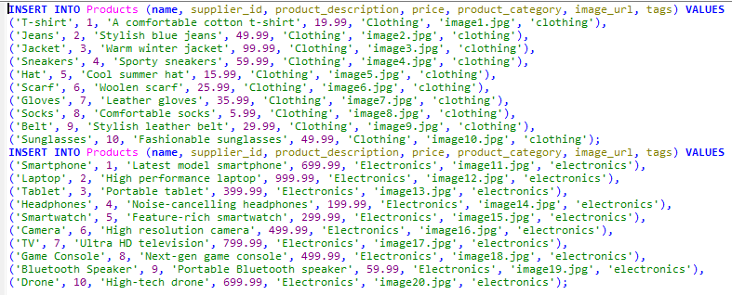

**Populating orders and order items tables:**

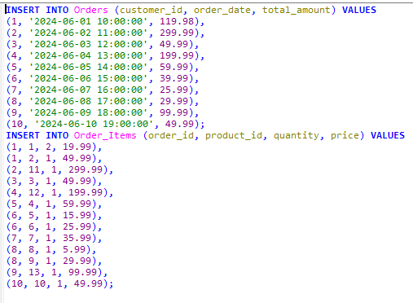

**Populating comments table:**

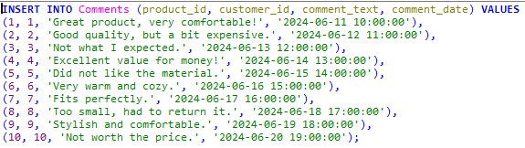

**Populating returns table:**

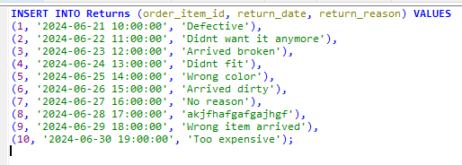

**Queries:**

* Query to fetch product details supplied by a specific supplier:

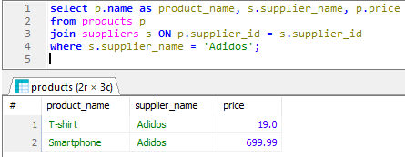

* Query to fetch customer details along with their last order date:

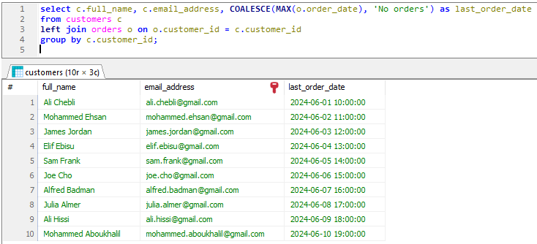

* Query to fetch product name, order date, and customer details for each order item:

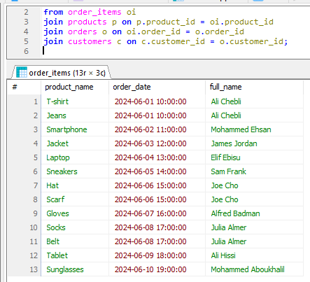

* Query to fetch product name and total quantity ordered:

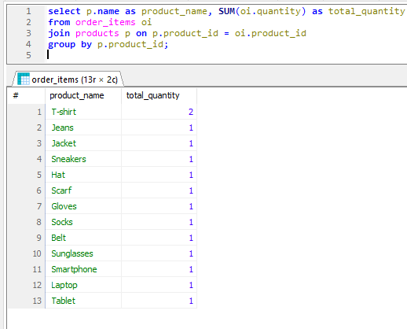

* Query to fetch customer names and the number of comments they have made:

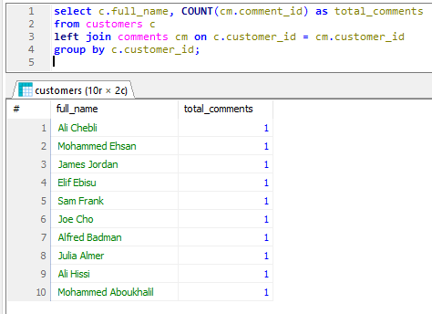

* Query to fetch all orders placed in the last 500 days:

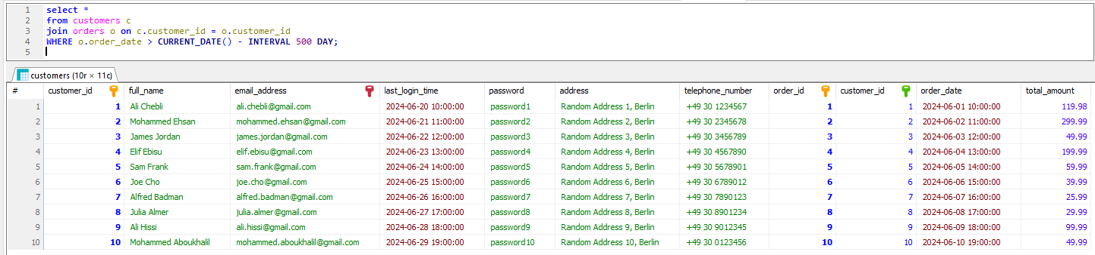

* Query to fetch all customer email addresses:

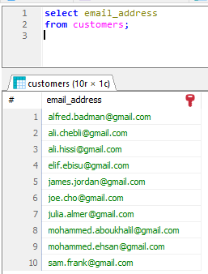

* Query to fetch supplier names and the number of products they supply:

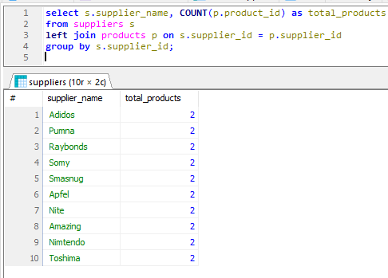

* Query to fetch customers with their maximum order total amount:

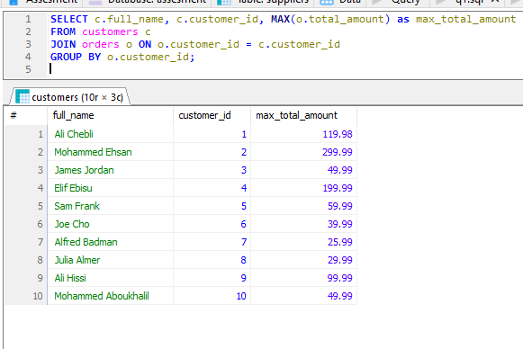

* Query to fetch products with total order amount greater than 100 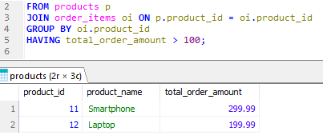
* Query to fetch products starting with 'J' that have been ordered:

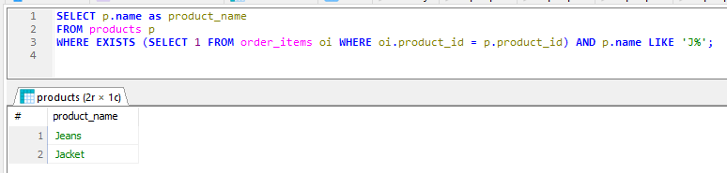

* Query to fetch customers with their order count and total amount, partitioned by order date:

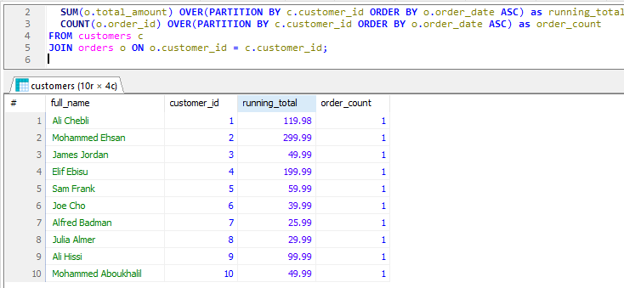

* Project repository:
* https://github.com/Hadialishibli/Database-assesment.git